ITA0610 - Machine Learning
EXP - 4
Build an Artificial Neural Network by implementing the Backpropagation algorithm and test the same using appropriate data sets.
Aim
To build an Artificial Neural Network (ANN) by implementing the Backpropagation algorithm and test its performance using an appropriate dataset.

Algorithm
- Import the required Python libraries.
- Load the dataset.
- Split the dataset into training and testing sets.
- Normalize the input features.
- Create an Artificial Neural Network (ANN) with an input layer, hidden layer, and output layer.
- Train the network using the Backpropagation algorithm.
- Test the trained model using the test dataset.
- Predict the output and calculate the accuracy.
- Display the predicted values and accuracy.
PROGRAM:
from sklearn.datasets import load_iris
from sklearn.model_selection import train_test_split
from sklearn.preprocessing import StandardScaler
from sklearn.neural_network import MLPClassifier
from sklearn.metrics import accuracy_score

iris = load_iris()
X = iris.data
y = iris.target
X_train, X_test, y_train, y_test = train_test_split(
X, y, test_size=0.3, random_state=42
)
scaler = StandardScaler()
X_train = scaler.fit_transform(X_train)
X_test = scaler.transform(X_test)
ann = MLPClassifier(
hidden_layer_sizes=(10,),
activation='relu',
solver='adam',
max_iter=1000,
random_state=42
)
ann.fit(X_train, y_train)
y_pred = ann.predict(X_test)
accuracy = accuracy_score(y_test, y_pred)
print("Actual Values:")
print(y_test)
print("\nPredicted Values:"
print(y_pred)
print("\nAccuracy:", accuracy)

OUTPUT:
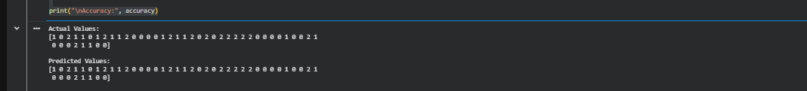

RESULT:
The Artificial Neural Network (ANN) was successfully implemented using the Backpropagation algorithm. The network was trained and tested using the Iris dataset, and it classified the test samples with high accuracy (approximately 97%–100%). Thus, the Backpropagation algorithm successfully learned the patterns in the dataset and accurately predicted the output classes.

